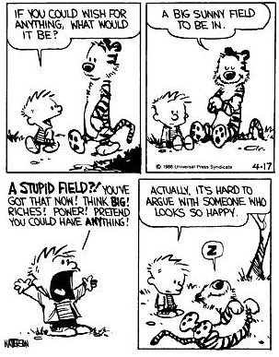
The Transcendentalists
Wrap-Up Essay

Walt Whitman, in Part 47 of “Song of Myself,” says…

“He most honors my style who learns under it to destroy the teacher.”

In class, we explored the Transcendental ideas of:

* Living simply
* Finding truth in nature
* Finding spiritual well-being within the self
* Embracing independence
* Foregoing “organized religion”

We read the following pieces:

* “Self-Reliance” and “Nature” (Emerson)
* “Walden” and “Civil Disobedience” (Thoreau)
* “Woman in 19th Century” (Fuller)
* Selected poetry (Dickinson and Whitman)

Write a multi-paragraph essay that explains how Whitman’s statement fits in with the Transcendental ideas. How did Emerson, Thoreau, Fuller, Dickinson, and Whitman encourage the reader to “destroy the teacher?”

Your essay should follow the basic format of:
* Introductory paragraph
* Supporting paragraphs (Can be done by author or by genre)
* Conclusion paragraph

Remember to stay focused on the idea of “destroying the teacher.” This obviously doesn’t mean literally. Think big and metaphorical.

