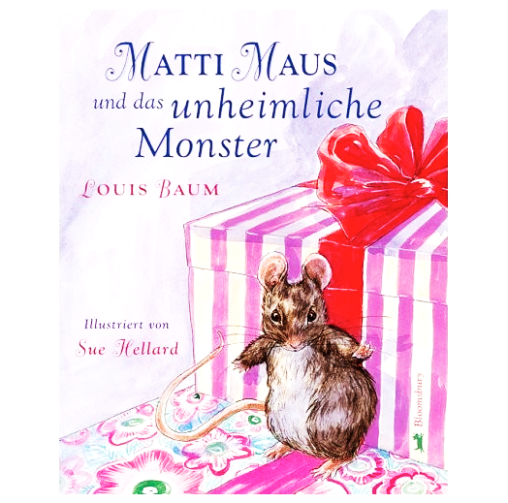
The uncanny (Das Unheimliche, "the opposite of what is familiar") is a Freudian concept of an instance where something can be familiar, yet foreign at the same time, resulting in a feeling of it being uncomfortably strange or uncomfortably familiar.

In this Gothic Literature unit, you have read/seen:

“The Raven” Edgar Allan Poe p. 438
“The Tell-Tale Heart” Edgar Allan Poe video
“Edward Scissorhands” Tim Burton video
“The Minister’s Black Veil” Nathaniel Hawthorne p. 458
“The Masque of the Red Death” Edgar Allan Poe p. 428
“Sorry, Right Number” Stephen King booklet
“Here There be Tygers” Stephen King handout
“Word Processor of the Gods” Stephen King video

As a final task in this Gothic Literature unit, you are to examine the concept of Das Unheimliche in these pieces of fiction.

- Choose the three pieces that you feel most effectively incorporate this idea in the story.
- Explore the idea of “strangeness within the familiar” in each of the three you choose.
- Use solid, concrete examples/quotes/details from the text or plot to support your choices. You should have no less than four pieces of evidence from each of the three works.
- Remember that organization is key. Don’t stress about how many paragraphs you’ll be writing. Consider each a file folder and use them accordingly.
- The completed essay is due _________________________________________.

