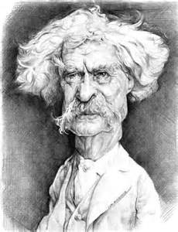
Mark Twain
and the
American Landscape

As a wrap-up to our Twain study, you are to complete a “mini-research” project and a narrative essay.

“Mini-Research” (200 points)

Twain is famous for using humor, wit, and sarcasm to make valid points about human nature and our relationships with one another. Using three pieces of Twain’s work, compose a multiparagraph essay that analyzes this idea. You will be graded on:

- organization (think of each paragraph as a file folder)
- proper and appropriate use of quotes from his texts
- use of standard, correct English (punctuation, spelling, paragraphing)

“Narrative” (150 points)

As “The Father of American Literature,” Twain is most noted for bringing distinct parts of America to life by using the writing technique of Regionalism. America is a metaphorical quilt with many patches, and each different one makes the whole more beautiful. For your narrative, you are to describe how you fit into this quilt. How are you a snapshot of a piece of America? You will be graded on the same criteria listed above, but since this is a narrative piece, it will be more personal and informal. You are simply telling your story. This should be about 400-500 words. Use details to bring your narrative to life.

