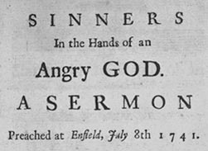 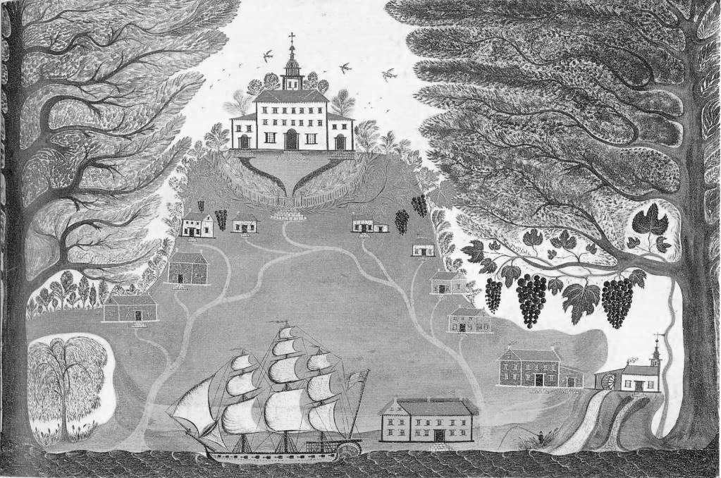 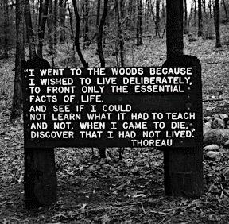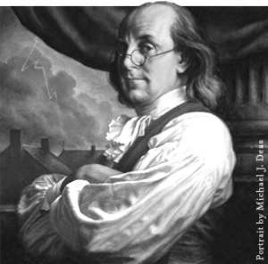  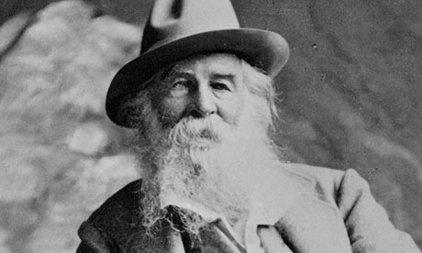

English 11

The Quest for Independence

* Develop awareness of history and culture

* Evaluate/Interpret variety of genres

* Use all steps of the writing process skillfully

* Use correct English in speaking and writing

* Use appropriate media sources for research

* Produce MLA-formatted research writing

## Objectives:

Bradford, Edwards, Jefferson, Franklin, Henry, Longfellow, Emerson, Thoreau, Whitman,

Hughes, Dickinson, Irving, Truth, Huxley, Shakespeare, Poe, Hawthorne, Hansberry, Fitzgerald

Contents:

1 – Objectives

2 – Calendar, Description, Details

3 – Routines, Expectations, Projects

4 – Disclaimer, Contact Info

A Brief Description:

This course is a graduation requirement. It is a survey of literature from the arrival of the first settlers and the American Revolution through the Civil War era, covering all major genres. Reading, and writing a great deal about what we read, is going to comprise the lion’s share of this course. Finally, correct use of grammar is an expectation in all assignments.

**Vestibulum vehicula purus sed urna.**

Course Details:

Text – McDougall Littell American Literature

Necessities – pen/pencil, notebook (marble composition recommended), folder for handouts

WORK TORN FROM SPIRAL NOTEBOOKS WILL NOT BE ACCEPTED.

Unit 1 – An Emerging Nation

Texts include writing from the original colonists and writers of the constitution.

Unit 2 – American Romantics

With a focus on poetry, this unit includes writing that relates experiences of men and women searching for inner strength and resilience.

Unit 3 – Civil War

This unit includes a selection of Civil-War era literature, including original documents, diaries, and speeches as well as fiction.

Unit 4 – Novel Study

This final unit will require an in-depth reading and analysis of a novel, either as a class or in small groups.

### Course Calendar:

Projects…

You will be periodically required to write multi-paragraph essays based on texts and media presented. Also, there is a required analytical research paper that is to be formally written in MLA standard format. It will be based on *Brave New World*, and class time will be spent on research and drafting.

**Attendance:** Regular attendance is essential for success in this course. Also, when you are here, be “here.” Don’t just take a seat and use oxygen – make your time in class count.

**Participation:** When participating in class discussions (which you are expected to do), I ask that you are thoughtful, respectful, and focused. Participation also means taking notes on class discussions and maintaining a functional notebook (quizzes on these periodically).

**Grading:** Assignments are worth a set amount of points based on complexity and difficulty. The 10-point scale following county policy is used. Q1 is worth 40% of your course grade, Q2 worth another 40%, and your final exam is the remaining 20%.

**Assignments and Assessments:** Daily work will include a variety of assignments, some to turn in and some to keep in your notes. Collected work is generally due the day given or the next day unless noted otherwise. Notebook quizzes and tests will be given for each main piece of literature.

**Missing or Late Work:** Missing work earns a zero. Late work will receive a 10% deduction each day late for two days – past that, it is unacceptable.

**Work Ethic:** Maintain neat notes, have materials with you, and be responsible for your own learning experience. Class does not end until I dismiss you - not the bell.

**Electronics:** Keep it away or it will be confiscated.

Routines, Policies, and Expectations…

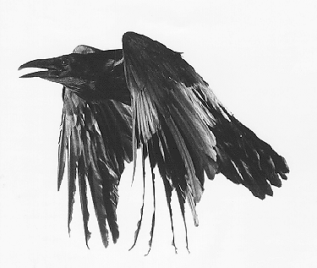 

In this classroom, you will be expected to behave in an adult manner. This means showing respect to all, regardless of differences of any type. I consider the classroom to be a sanctuary for learning, where every student can feel safe to express himself or herself without fear of criticism or teasing. We are all unique and none of us is perfect, so everyone must be accepted equally. We will be reading, writing, talking, and learning together for the entire semester, and in order for this to work and be pleasant for everyone, we must behave as respectful, responsible members of our classroom community. I will show you respect and I expect it to be shown in return. Any language or behavior that may be interpreted as insulting is not welcome as it destroys the safe atmosphere. I have faith that everyone will abide by these expectations in order to have the best semester possible. If not, I want you to have faith that offenders will be asked to vacate the room until they feel ready to return in a functional manner.

In order to keep track of the assignments, due dates, and other relevant information for this course, follow me on Twitter at:

@readwithgarrett

You can also find information on my website at

http://angiegarrett.weebly.com

Here, you can see updates, participate in online discussions, and submit work to the online dropbox.

I can also be reached most easily by email at:

[a.smoorenburg@hotmail.com](mailto:a.smoorenburg@hotmail.com)

or

[angela_garrett@mail.cl.k12.md.us](mailto:angela_garrett@mail.cl.k12.md.us)

### For Further Information…

*Vestibulum ante ipsum primis in faucibus orci luctus et ultrices posuere cubilia Curae; Cras ornare dui ut neque. Pellentesque dignissim, ligula non dictum lobortis, pede arcu sodales odio, sit amet aliquam lorem arcu non quam. Suspendisse potenti.*

Disclaimer…