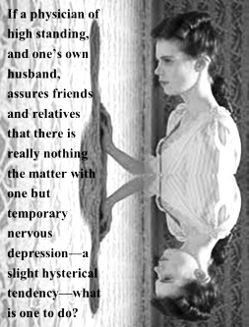
Yellow Wallpaper
Analytical Assessment

This analysis is due __________________________. You may accomplish this in one of the following ways:

- Google Slides (shared via your county-issued account)
- Google Docs Essay (shared via your county-issued account)
- Google Drawing (shared via your county-issued account)
- Prezi
- Weebly site

Be sure to support your statements and ideas with textual citations from the story. A minimum of eight to ten substantial quotes will be sufficient, but there is nothing wrong with going beyond that to strengthen your ideas.

Choose one prompt related to the short story:

- Issue of control: Discuss John’s control over his wife as both her husband and doctor. How does this control shift by the end of the story?

- Gender roles: Discuss women’s passivity, relegation to the house, and social expectations.

- How is “The Yellow Wallpaper” an accurate, useful description of the descent into madness, or into the process of going mad?

- How does the changing description of the wallpaper reflect the narrator's changing character?

- At one point the narrator refers to John…"because he is so wise and because he loves me so." Do you feel John is wise and loving? Explain.

- Looking at the minor characters (Mary, Jennie, etc.), analyze the view of women during this time period. Use the text to support your ideas, providing specific examples.

- Which is more injurious to the narrator--the psychological demons (internal) or the societal demons (external) she faces? Explain.

- Who bears responsibility for the narrator's ultimate madness? If not a person, what factors result in her descent? Explain.

- Universalize the primary metaphor of the story. Do we all have our own “Yellow Wallpaper”? Something to hate, then to tolerate, then to become fascinated by, then to become obsessed with, to our detriment?

Choose one of Gilman’s quotes to connect to the short story.

Again, you will need to pull support from the short story. For this portion of the assignment, however, paraphrasing is acceptable.

- “Here she comes, running, out of prison and off the pedestal: chains off, crown off, halo off, just a live woman.”
― Charlotte Perkins Gilman

- “Through it [literature] we know the past, govern the present, and influence the future.”
― Charlotte Perkins Gilman, The Man-Made World

- “In a sick society, women who have difficulty fitting in are not ill but demonstrating a healthy and positive response.”
― Charlotte Perkins Gilman

- “This is the woman's century, the first chance for the mother of the world to rise to her full place . . . and the world waits while she powders her nose.”
― Charlotte Perkins Gilman

- “There is no female mind. The brain is not an organ of sex. May as well speak of a female liver.”
― Charlotte Perkins Gilman, Women and Economics

