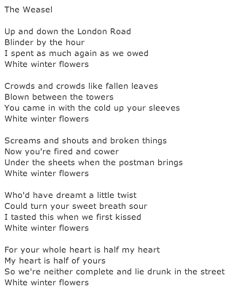

FYI…

* Kafka
  + existential
  + people helpless, disoriented, and overpowered by life
  + writing highlighted “irrationality at the root of a supposedly rational world”
* Civil Service Job
  + IRS, MVA, USPS, etc.

*by Jacob Polley*

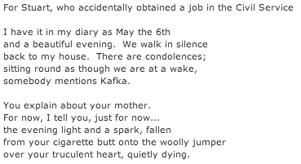

*by Leontia Flynn*

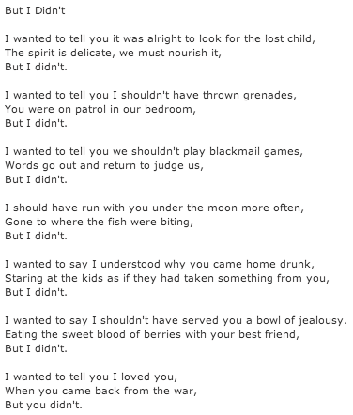

In your notebooks, write a brief summary of each poem. What is happening, and how does failure take place?

*by Gary Langford*