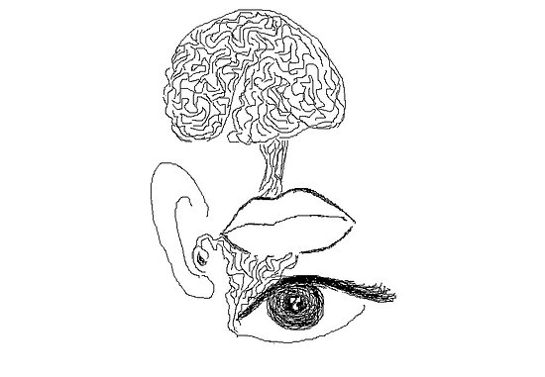
Stream-of-Consciousness

The characteristics are…
- Moves from the past to the present (a flashback-like technique)
- Involves monologue and dialogue (monologue shares private thoughts or feelings)
- Indirectly reveals characteristics of the character speaking
- Thoughts are sometimes interrupted by interjections
- Thoughts are often disjointed, illogical, or fragmented – one thought leads to another but the flow is not always logical
- Usually written in the present tense
- The use of stream of consciousness must serve to advance a storyline
- An epiphany occurs – through a process of recognition that involves an awareness of the connections between subconscious and conscious reality

The excerpt from the first chapter of Kerouac’s novel On the Road is an excellent example of the stream of consciousness style.

They rushed down the street together digging everything in the early way they had which has later now become so much sadder and perceptive, but then they danced down the street like dingledodies and I shambled after as usual as I’ve been doing all my life after people that interest me, because the only people that interest me are the mad ones, the ones who are mad to live, mad to talk, desirous of everything at the same time, the ones that never yearn or say a commonplace thing… but burn, burn, burn, like roman candles across the night. (Kerouac p.8)

Buddhism
The phrase "stream of consciousness" (Pali; viññāna-sota) occurs in early Buddhist scriptures. The Yogachara school of Mahayana Buddhism developed the idea into a thorough theory of mind.
Hammalawa Saddhatissa Mahathera writes: "The stream of consciousness, flowing through many lives, is as changing as a stream of water. This is the anatta doctrine of Buddhism as concerns the individual being."
Your assignment is to write a stream-of-consciousness piece. It should exhibit the characteristics listed above. The best advice is to start with a story that involves multisensory details about a task/activity/experience with which you are well-acquainted. (I’m a bread-baker, so I’m choosing that.) Write about that as if you were actually immersed in it.

