“If you'll be my Dixie Chicken, I'll be your Tennessee Lamb.”
Exploring the South in Literature

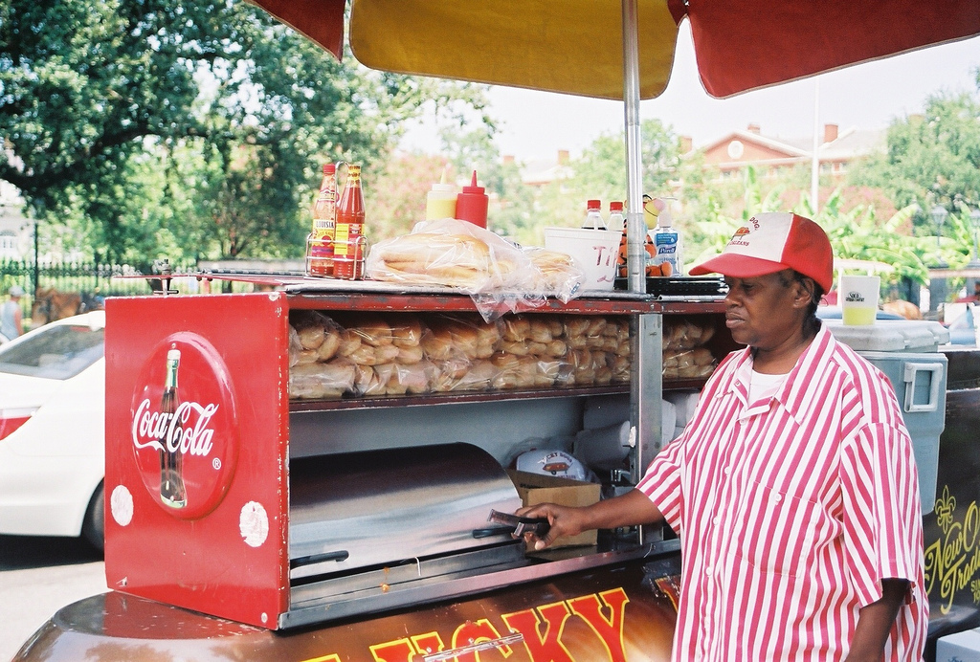
Eudora Welty – “A Worn Path”
William Faulkner – “A Rose for Emily”
Flannery O’Connor – “The Life You Save May Be Your Own”
Walker Percy – “The Moviegoer”
John Kennedy Toole – “A Confederacy of Dunces”
Bob Dylan – “Chronicles, Vol. 1, excerpt”
Kathryn Stockett – “The Help”

The writings from these seven authors are all centered on some aspect of life in the south. Choose one of the following essay topics and use the pieces we read in class to construct a coherent, well-supported response.

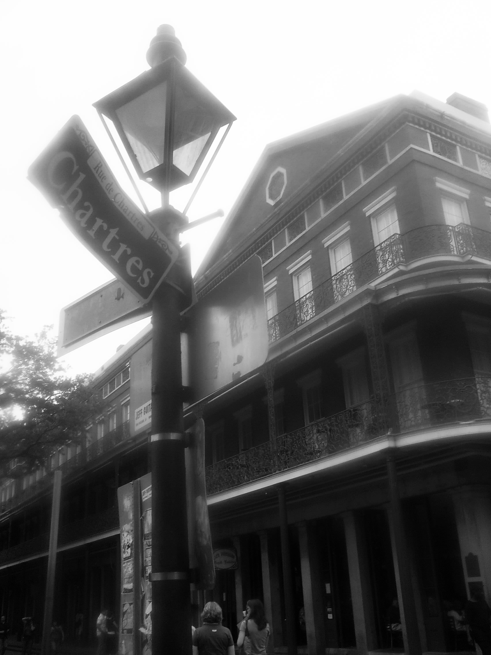
Theme – What is the author saying about the south? Its people? Their values and priorities? Social status? Family relationships and expectations? Social relationships and expectations?

Find three (or more) works that share a theme and discuss it fully.

Setting – How does the setting play a major role in the plot? Is it so central that the story couldn’t have taken place elsewhere?

Find three (or more) works that share this feature and discuss it fully.

Imagery – Which authors paint glorious, vibrant pictures with their words? Which authors create brushstrokes of sadness or isolation? In which pieces can you feel yourself immersed in the scenes and landscapes of The South?
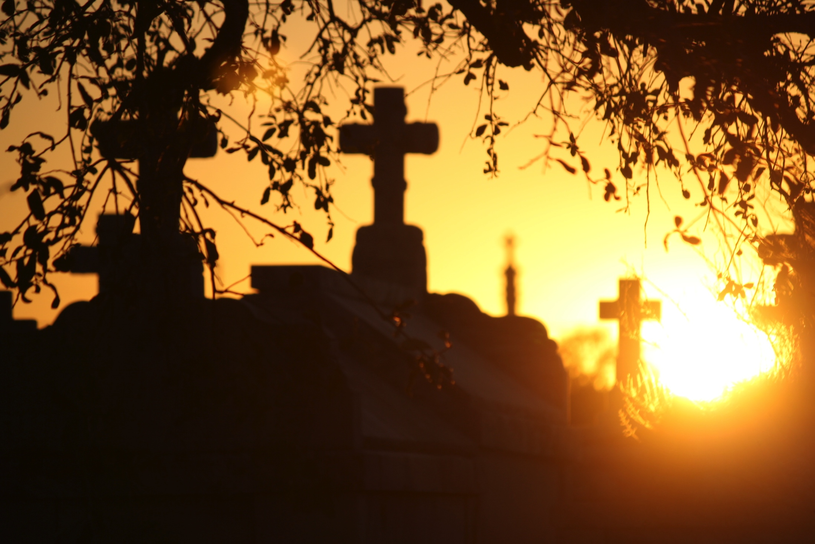
Find three (or more) works that share this feature and discuss it fully.

- Your final essay should be two-three typed pages, double-spaced, in 12-point Times New Roman or another basic font, with 1-inch margins.

- Remember to cite your sources as you quote them (Yes. Quote them.), using the proper APA format.

- You are to also create a “Works Cited” list at the end of your paper. This is to be done in APA format as well, listing each of the pieces you chose for your essay.

